RI Foreign Minister: Preventive Diplomacy Vital for Averting Regional Conflict

Jakarta, 14 July 2023. Minister for Foreign Affairs Retno Marsudi chaired the 30th ASEAN Regional Forum (ARF) meeting on Friday (14/7) in Jakarta. During the meeting, Retno said that the ARF must have a preventive diplomacy role to maintain peace and prevent conflicts in the region.

The ASEAN Regional Forum (ARF) was established in 1994 to shape the post-Cold War regional security architecture through confidence building measures that promote dialogue and consultation. However, the current regional security landscape has undergone much change due to increasing great power rivalry in the region.

In her opening remarks, Foreign Minister Retno said that the "tit for tat" approach has created a deep crisis of trust, hindering cooperation. She also underlined the potential for conflict stemming from territorial disputes and ethnic conflicts. The challenge has become more complex with the emergence of non-traditional security issues such as terrorism, human trafficking, and maritime piracy.

"This complexity requires us to better manage potential conflicts. We must use the ARF as a vehicle to seek peace and prevent conflicts in the region," Retno said.

Retno emphasised the importance of turning trust deficit into strategic trust. She also emphasised the need to build cooperation that directly benefits the people in the region. For this reason, Indonesia continues to encourage concrete cooperation in the vision of the ASEAN Outlook on the Indo-Pacific.

"The cooperation is not only beneficial in the economic field, but can also encourage strategic cooperation amid the current geopolitical situation," Retno said.

Furthermore, Retno said that it is time for the ARF to transform to the next stage to become a preventive diplomacy mechanism that is more responsive in facing security challenges in the region.

In her national statement, Retno made three recommendations to make the ARF play a role in preventive diplomacy:

First, applying the norms and values upheld by ASEAN, as stated in the ASEAN Charter and the Treaty of Amity and Cooperation (TAC).

"We need guidelines to prevent conflict. In this case, because the maritime domain holds many potential conflicts, we need to establish the rules of the game, especially in the maritime domain," Retno said.

Second, ARF must encourage concrete cooperation. Retno said that ARF must become an action-oriented mechanism to face regional security challenges. There are a number of collaborations that can be carried out such as capacity building programmes and joint exercises. The concrete cooperation must be inclusive and not threaten other parties.

"This is a form of preventive diplomacy that can avert conflicts," Retno said.

Third, strengthening the institutional capacity of the ARF. In this regard, Retno urged for strengthening the role of the ARF Chair and Friends of the ARF Chair. Retno also encouraged the ARF Track II mechanism. Retno further emphasised that to advance the ARF mechanism to the preventive diplomacy stage, political will from all parties is needed.

The 30th ARF meeting highlighted a number of regional and non-regional security issues including Myanmar, South China Sea maritime security, denuclearisation on the Korean Peninsula, and the importance of an Indo-Pacific region free of nuclear weapons. Issues outside the region are still dominated by the impact of the war in Ukraine.

The meeting’s participants also expressed appreciation for Indonesia's leadership in ASEAN, especially in encouraging the implementation of the Five Point Consensus (5PC) in Myanmar. Meeting participants also affirmed support for ASEAN centrality and respect for international law, including the UN Charter.

***

For further information, please contact the following:

Director for Information and Media of the Ministry of Foreign Affairs - Hartyo Harkomoyo (+62811831899)

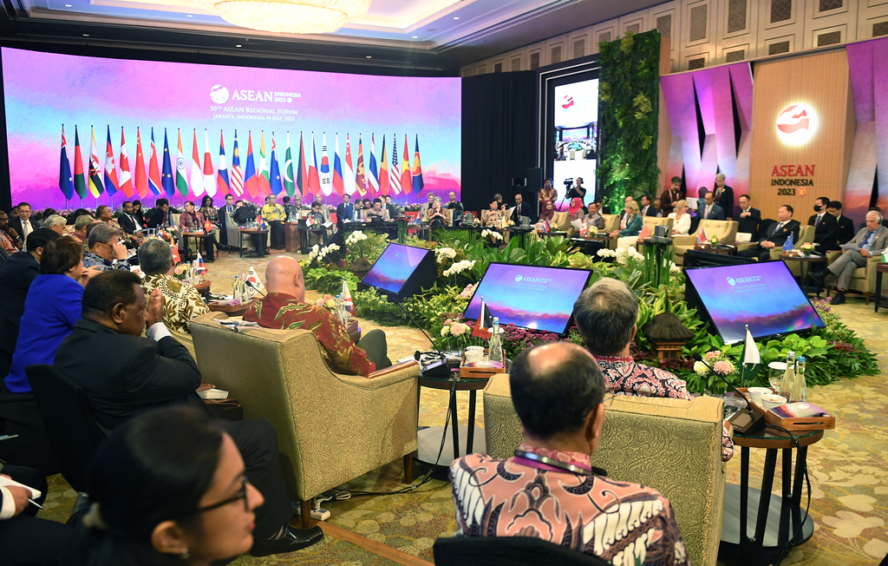

Minister for Foreign Affairs Retno Marsudi emphasized that the ASEAN Regional Forum (ARF) must have a preventive diplomacy role to maintain peace and prevent conflicts in the region during the 30th ARF meeting in Jakarta (14/7) (Photo: Ministry of Foreign Affairs of Indonesia).

